**CIS Hardening Process:**

CIS Benchmark Hardening/Vulnerability Checklists. The Center for Internet Security is the primary recognized industry-standard for secure configuration guidance, developing comprehensive, consensus-derived checklists to help identify and mitigate known security vulnerabilities across a wide range of platforms.

Step-by-Step Process :

1. Download the below CIS base template



1. Open the AWS console >> Cloud formation >> Click on Create Stack.

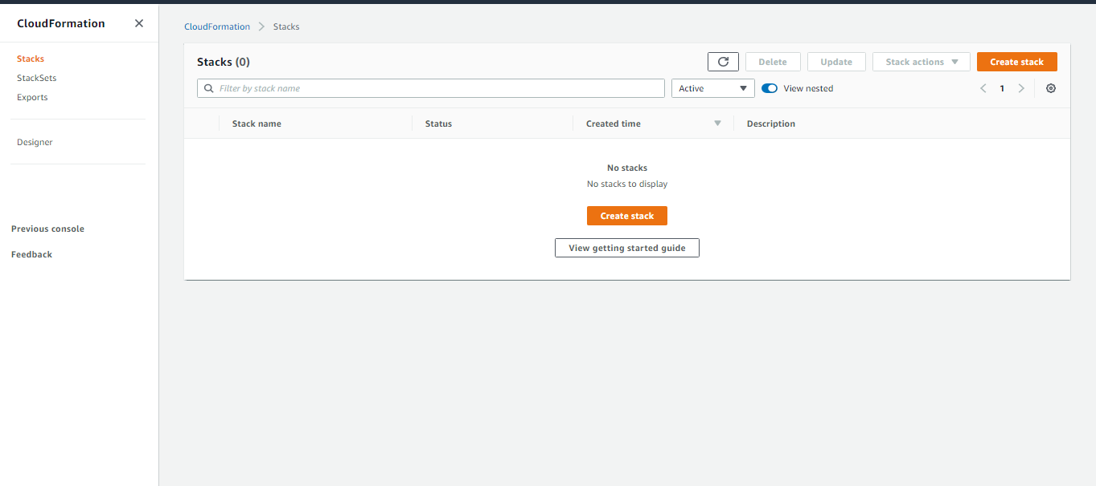

1. Upload the template by choosing the CIS base template >> Next.

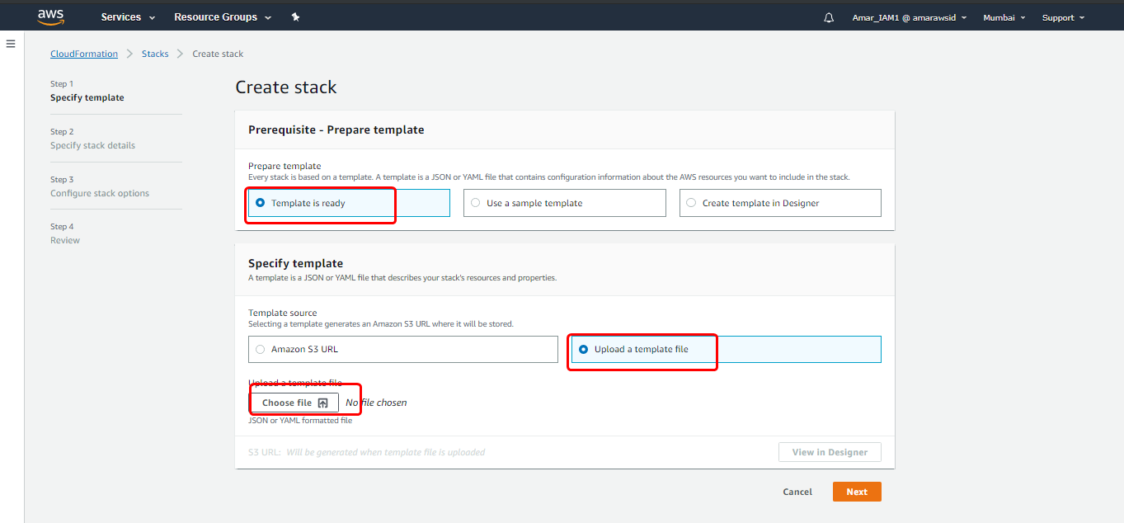

1. Choose the Profile level – 2

Notification Address – [pmo@minfytech.com](mailto:pmo@minfytech.com)

Configure Cloud Trail – Yes

Configure AWS config - Yes

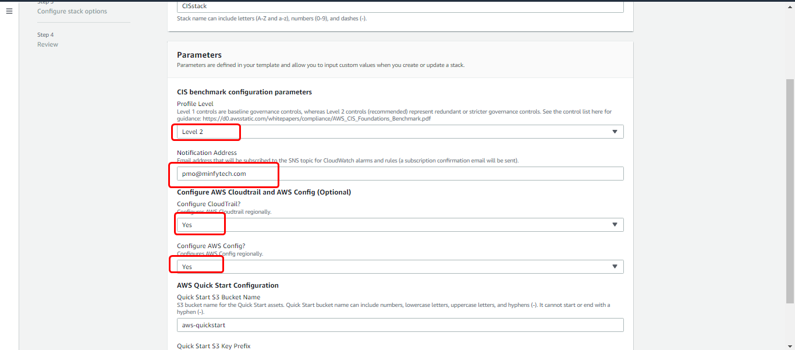

1. Provide the Tag name - <Account name_CIS>

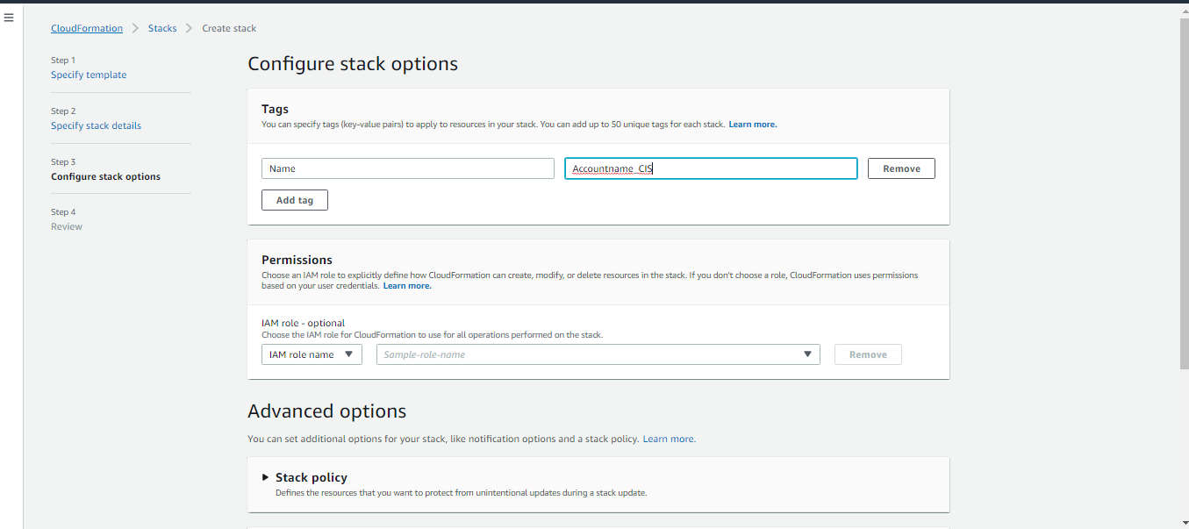

1. Click next and select the acknowledge both the paramerts and click on Create Stack.

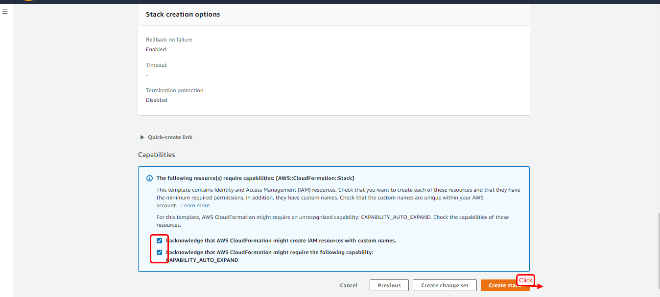

1. You should find the Events getting created.

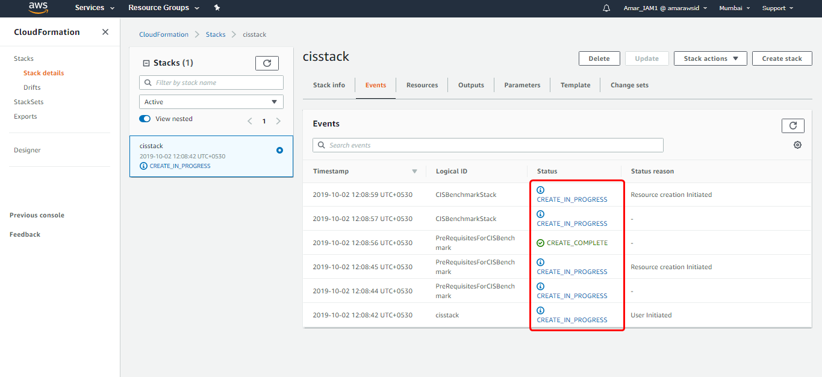

1. CIS Hardening has been completed.

